If this email does not display correctly, please click here

Dear Headteacher
With the recent spate of Government cutbacks, it’s comforting to know that New Forest Log Cabins are building Log Classrooms, Canteen Facilities, Sports Pavilions and Temporary Log Buildings that meet Ofsted and Building Control requirements, and what’s more, they are extremely Energy Efficient, have a very low Carbon Footprint and are fantastic places for children to learn. [Click here for Education Press Release]  Feedback from Head teachers and Teaching staff have demonstrated that the learning environment created by our Log Classrooms increases children’s awareness and they are able to focus better because of the ambiance created within the Log Building. This also goes for teachers as well since the open vaulted ceilings and natural feeling of wood is a great place for both Teachers and Children to work.  So those are just a couple of plus points as to why you should consider a Log Building from New Forest Log Cabins as an alternative to conventional brick or temporary, outdated buildings. But that’s not all, the big benefit is that they cost 30% less to build than a conventional classroom and cost 30% less to heat.  To find more about how our Log Classrooms and Buildings can offer a cost effective solution for Log Classrooms, Sports Pavilions, Canteens and Schools Buildings, please click here to receive a Log Schools Information Pack .  Best regards,  John Rudd  Sales Director  sales@newforestlogcabins.co.uk  www.newforestlogcabins.co.uk  tel: 01202 868844 mobile: 07802 245474 fax: 01202 237979  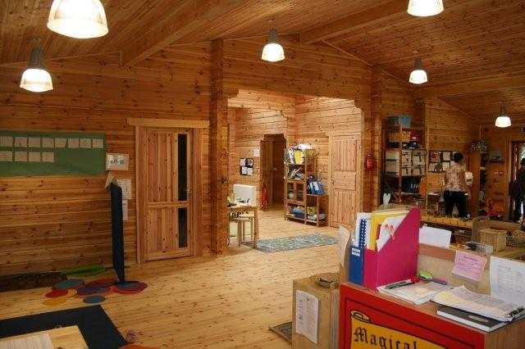 | 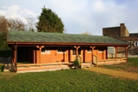  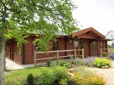  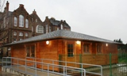  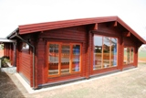  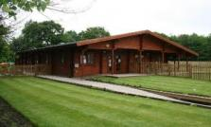  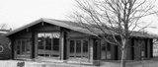  Link to Schools Designs  Brochure
New Forest Log Cabins Ltd, Wyevale Garden Centre, 229 Wimborne Road West, Wimborne, Dorset, BH21 2DN.

